The Tribe Of Benjamin
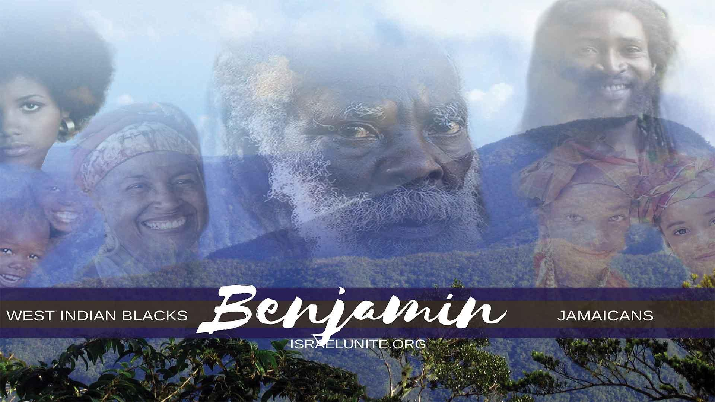

Genesis 35:18 “And it came to pass, as her soul was in departing: (for she died) that she called his name Benoni: but his father called him Benjamin.”
Genesis 49:1 “And Jacob called unto his sons, and said, Gather yourselves together, that I may tell you that which shall befall you in the last days.” The last days occur from the days of Christ till today.
The Tribe of Benjamin- Sold into Captivity By The Africans And The Arabs
The tribe of Benjamin (West Indies), along with Judah and Levi, were sold into captivity (by the Africans and the Arabs) to the white-man. The white man then transported them in chains on slave ships to Jamaica, and various West Indian islands to serve hard bondage as slaves.
Maroons
During slavery we had the 1 “Maroons “, The word Maroon is Latin meaning wolf, primarily throughout the West Indies, which were runaway slaves that fled to the mountains and swamps of the islands. The white man could not subdue these men because they knew the land very well and could survive on their own; living off the land.
The Maroons firmly believed in liberty or death, in other words, if they could not be free they would rather be dead.
Genesis 49:27: “Benjamin shall ravin as a wolf: in the morning he shall devour the prey and at night he shall divide the spoil.”
“Benjamin shall ravin as a wolf…” The word 2“ravin” in this sense means speak boldly/harshly. The tribe of Benjamin, ravin as wolves through their music by speaking the truth that they are Israelites and God will judge Babylon (America and the white race) for the injustice they have done to the children of Israel (slavery, raping our women, dividing the families etc.). For example, in Jamaica, and the other Caribbean islands, the white man buys up the best parts of the land, and have the people work the land for almost nothing (slave labor). The tribe of Benjamin, ”ravin” about their suffering and oppression, by singing about it in their music; songs contrary to what was forced upon them by the white man through his religions, that Christ and the Israelites are white etc.
Certain artists speak through their music of America being Babylon (Psalms 137 proves America is Babylon) and how it’s going to fall (Revelation 18:19-21); that Christ, Solomon etc. are black according to the Bible, and also sing about themselves being Israelites. For example Luciano (“The white man’s Kingdom is falling…”), Dennis Brown (“The Black Revolution…”), Peter Tosh (“Oppressor man where you gonna run to…”), Burning Spear (“Do you remember the days of slavery…”), Junior Reed (“The Lord is my Shepherd…”). Anthony B (“Fire pan Rome…) also “They (white-man) can’t run away from the Judgement Day” and “By the rivers of Babylon…” by various artists. Most reggae artists get their inspiration from the Bible; from books like Psalms and Revelation.
When the scripture says; “…As a wolf…” meaning the same way a wolf howls at its prey before attacking it; is the same way the tribe of Benjamin, are howling at the white race through their music.
Genesis 49:27 continues, “…In the Morning He Shall Devour The Prey”, the morning represents the tribe of Benjamin, being raised up in rulership in the Kingdom of Heaven.
Isaiah 9:2, “The people that walked in darkness (slavery, not knowing your nationality etc.) have seen a great light (Christ is the light and wisdom, John 8:12 – the kingdom of heaven): they that dwell in the land of the shadow of death (America), upon them hath the light shined.”
For a long time, the nation of Israel, has been in darkness (captivity etc.). We were brought here as slaves, our women and children were raped, and our families destroyed. We were burnt and lynched and had no knowledge of who we were according to the Bible.
“…He shall devour the prey…” meaning in the Kingdom of Heaven, the tribe of Benjamin, alongside his brethren are going to destroy and enslave the white man and all nations; read Psalms 149:6-9 and Obadiah 1:15-19
Verse 27 continues, and at night he shall divide the spoil”, the night represents the end of the white man’s rulership, with the second coming of Christ; read Zephaniah 1:14- 15. It will be the white man’s night (captivity) and our day (rulership over the nations). “…He shall divide the spoil.” This means after the white man and the nations has been enslaved, Benjamin, and the other tribes will divide the riches and wealth of the nations, read Jeremiah 30:16
Deuteronomy 33:12, “And of Benjamin he said, the beloved of the Lord shall dwell in safety by him; and the Lord shall cover him all the day long. and he shall dwell between his shoulders
“…Shall dwell in safety by him..” this is talking about the Most High, protecting Benjamin, from his enemies and that the white man during slavery did not kill them off. In the end, the tribe of Benjamin, shall “devour the prey”, which is the white man and the other nations for enslaving them.
Deuteronomy 33:12 continues, “…And the Lord shall cover him all the day long…” meaning the Most High, was going to bless Benjamin, with good weather and land etc.
Verse 12 continues, “…And he shall dwell between his shoulders.” meaning between the heavens and the waters: good climate and good land to plant and grow crops.
The Following Are Facts Proving That The West Indians Are From The Tribe Of Benjamin
The following are facts discovered by a so-called Jew (Rabbi Matthew), after in depth study and research found in a book titled, “From Babylon to Timbuktu”, by Rudolph R. Windsor on page 133:
“Before Dr. Goodby published his book, “The Lost Tribes a Myth”, Rabbi Matthew organized a Hebrew congregation in 1918 and proclaimed that the black people of the United States and the West Indies are the original black Hebrews.”
The following is found in a book titled “Nature Knows no Color Line”, by J.A Rogers on page 123 & 130.
“Many of the Jews who were banished from Portugal by John II settled in the West Indies. John Bigelo, who visited Jamaica in 1850, saw the descendants of these Jews and says they were Negroid (Black).”

Bibliography
- “New Webster’s Dictionary and Thesaurus”, page 83
- “History of Slavery”, by Susan Everette
- “Nature Knows No Color Line”, by J.A Rogers
- “From Babylon to Timbuktu”, by Rudolph R. Windsor
- “Before the Mayflower”, by Lerone Bennette Junior
SHALOM

